
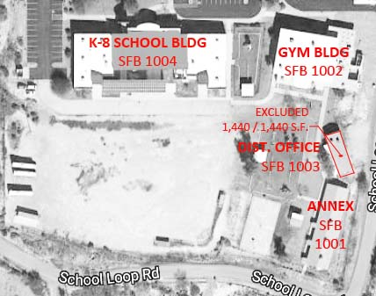

School: | Canon Elementary School  19630 E. School Loop Road, Black Canyon City, AZ 85324 |  |  | CTDS: | 130350101
Building No. | Building  Description | Building Use | Year Built | Grades Served | Gross Area | Gross Excluded | Net Area | Int Cord | SFB Fund
1001 | Annex | Speech/ Storage/ Classrooms | 1982 | E, M | 4,315 | 0 | 4,315 | N | N
1002 | Gymnasium | Gymnasium | 1989 | E, M | 13,823 | 0 | 13,823 | N | N
1003 | Mobile | District Office | 1985 | E, M | 1,440 | 1,440 | 0 | N | N
1004 | K-8 School | Classrooms | 2001 | E, M | 18,652 | 0 | 18,652 | Y | Y
Totals: |  |  |  |  | 38,230 | 1,440 | 36,790 | 1

